Birkbeck Students’ Union
Complaints and Grievance Policy

Approved by: Birkbeck Students’ Union Board of Trustees
Applies to: All Birkbeck students, elected officers, society committee members, volunteers, and SU staff.
Effective from: [Annual 1/1/2026)
Purpose
This policy provides a transparent, fair, and supportive process for resolving complaints and grievances within Birkbeck Students’ Union (BBKSU). It ensures that all members of the Birkbeck community are treated with dignity and respect, and that issues are addressed promptly, impartially, and in line with BBKSU’s core values of equality, accountability, and inclusion.
The aims of this policy are to:
- Provide a clear, fair, and transparent procedure for handling concerns.
- Encourage early and informal resolution where possible.
- Ensure serious matters are investigated thoroughly and impartially.
- Promote learning, improvement, and accountability within BBKSU.

Scope
This policy applies to complaints or grievances involving:
- Birkbeck Students’ Union services, decisions, or processes.
- Conduct of BBKSU officers, staff, or representatives.
- Issues within societies, clubs, or SU-affiliated groups.
- Breaches of BBKSU policies (e.g. Code of Conduct, EDI, Safeguarding).
This policy does not apply to:
- Academic matters (these follow Birkbeck, University of London’s Academic Complaints Procedure).
- Anonymous allegations without supporting evidence.

Principles
Birkbeck Students’ Union is committed to resolving complaints and grievances in a way that is:
- Fair: All parties are treated equally and given the opportunity to respond.
- Confidential: Information is shared only when necessary for investigation.
- Supportive: Advice and welfare assistance are available for all involved.
- Timely: Complaints are handled within clear and reasonable timeframes.
- Non-retaliatory: No individual will suffer a disadvantage for raising a genuine concern.

The Three Stages Stage 1 – Informal Resolution (within 10 working days) Where possible, complaints should be resolved informally at the earliest opportunity. The complainant should raise the issue directly with the relevant Manager by email.
The person receiving the informal complaint is responsible for providing a fair and timely response, normally within 10 working days of receiving the concern.
Possible outcomes of informal resolution include:
- Arranging a facilitated conversation or mediation.
- Providing an apology or clarification.
- Reminding staff, officers, or societies of EDI principles and Code of Conduct expectations.
- Offering additional training or reviewing procedures to prevent similar issues.
- Signposting to relevant University EDI or wellbeing services where appropriate.
If informal resolution is not possible or appropriate (for example, in cases involving discrimination or harassment), the complainant will be advised to proceed to Stage 2 – Formal Complaint.

Stage 2 – Formal Complaint / Grievance (within 20 working days)A formal complaint should be submitted via the Birkbeck Students’ Union Online Complaint Form. Formal complaints are investigated by a member of the SU Management Team or Senior Leadership Team.
The submission must include:
- A clear description of the issue.
- Names of those involved (where applicable).
- Relevant evidence or examples.
- The desired resolution or outcome.
Process:
- An acknowledgement will be sent within 5 working days of submission.
- The complaint will be assigned to an impartial Investigator (internal or external).
- The investigation may include interviews with those involved and review of supporting evidence.
- The Investigator will produce a written report outlining findings and recommendations.
Possible outcomes include:
• No case to answer – complaint not upheld.
• Informal action – apology, clarification, or mediation.
• Formal action – staff or officer disciplinary measures, mandatory training, or procedural/policy change.
• Partially upheld – with targeted recommendations for improvement.

Stage 3 – Appeal (within 10 working days of outcome)
Purpose: This stage provides the complainant with the right to appeal the outcome of a Stage 2 formal complaint or grievance. It ensures decisions are made fairly and in accordance with principles of natural justice and transparency. Appeals based solely on disagreement with the outcome or dissatisfaction with the decision will not be accepted.

Eligibility: Appeals may only be made after completion of Stage 2 and must be submitted within 10 working days of the Stage 2 outcome. Late appeals will not normally be considered unless exceptional circumstances can be proved.
Grounds for Appeal:
- Procedural Error – A material procedural error may have affected the outcome.
- Bias or Conflict of Interest – Credible evidence of bias or conflict of interest.
- New Evidence – Relevant evidence not previously available that may affect the outcome.
Appeals based solely on disagreement with the outcome will not be accepted.
Submitting an Appeal: Appeals must be submitted in writing to the Chair of the Board of Trustees via the Birkbeck Students’ Union: SU-committee@bbk.ac.uk
The submission must include:
- The appellant’s full name and contact details.
- The date of the Stage 2 decision letter.
- The specific ground(s) for appeal that is being relied upon.
- A statement explaining why the appellant believes the grounds apply.
- Any supporting evidence or documentation.

Process:
- Appeal submitted to the BBKSU Board of Trustees.
- Decision issued within 20 working days.
- Outcome is final within BBKSU procedures.

Record Keeping and Monitoring:
- All complaints are logged securely and stored confidentially by BBKSU management.
- An anonymized annual report summarising complaints, themes, and outcomes will be presented to the Board of Trustees to support continuous improvement.
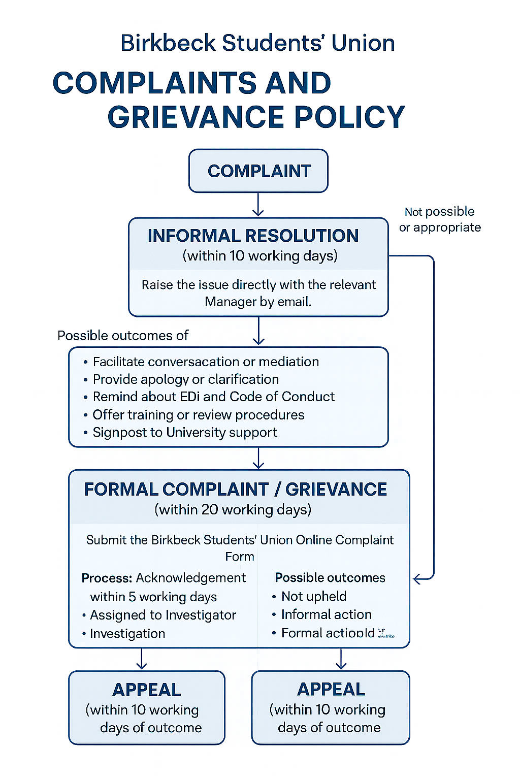
Reviewer : Michael Jones
Next review: 1/1/2027

